**RECRUITMENT WORK FLOW**

**BACKGROUD INVESTIGATION (OPTIONAL)**

**HRD RECRUITMENT STAFF** TO INPUT RESULT OF THE INVESTIGATION

**HRD RECRUITMENT STAFF** TOENDORSE APPLICANT’S DOCUMENTS TO REQUISITIONING DEPARTMENT OR SBU FOR REVIEW

**APPLICANTS**

**APPLICANT** TO FILL-UP THE EMPLOYEE DATA SHEET

**HRD RECRUITMENT STAFF** TO ENCODE THE APPLICANT INFORMATION ON THE SYSTEM

**SELECT CANDIDATES**

**HRD RECRUITMENT STAFF** TO SELECT CANDIDATE/S FROM THE LIST OF APPLICANTS (Internal/External)

**APPLICANT INITIAL INTERVIEW**

**HRD RECRUITMENT STAFF** TO INTERVIEW APPLICANTS ON THE LIST OF CANDIDATES

**APPLICANT EXAM (MANUAL PROCESS)**

**HRD RECRUITMENT STAFF** TO INPUT RESULT OF EXAM

**PRF CLOSING**

**HRD RECRUITMENT STAFF** TO MANUALLY CLOSE THE PRF UPON COMPLETION

**FINAL INTERVIEW**

**HRD RECRUITMENT STAFF** TOCOORDINATE WITH APPLICANT AND INTERVIEWER THE INTERVIEW SCHEDULE

**JOB OFFER**

**HRD RECRUITMENT STAFF** TOSCHEDULE THE APPLICANT FOR JOB OFFER

**PRE-EMPLOYMENT REQUIREMENTS**

**HRD RECRUITMENT STAFF** TOENTER THE DATE SUBMITTED PER REQUIREMENTS

**CREATE 201**

**HRD RECRUITMENT STAFF** TO TAG AS HIRED THE QUALIFIED APPLICANT/S AND WILL BE ADDED TO THE EMPLOYEE LIST

**CONTRACT SIGNING**

**HRD RECRUITMENT STAFF** TO PRINT THE CONTRACT

**.**

**A. Applicants**

**A1.0** Employee Data Sheet to be fill-up by the applicants

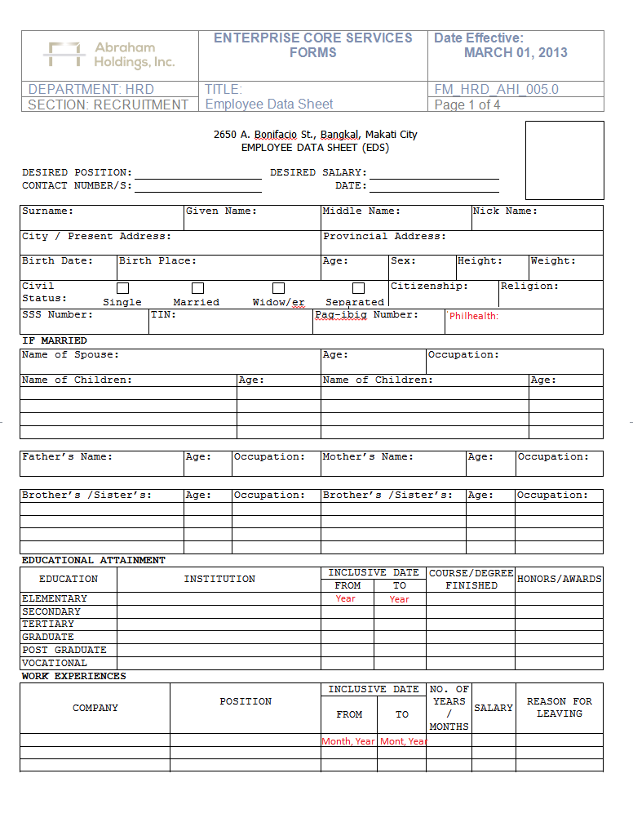

Addition field for Philhealth I.D.

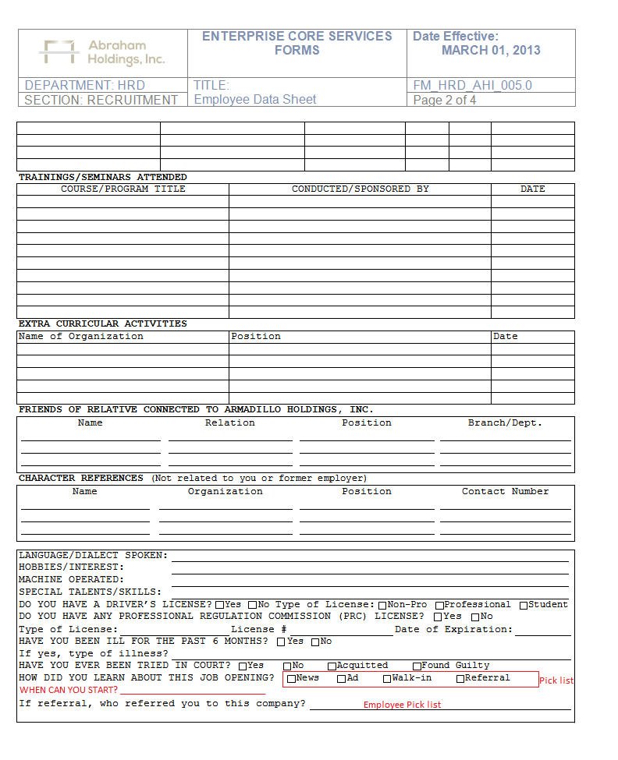

Additional field for the start date

Pick list w/ Master file entry

From employee pick list

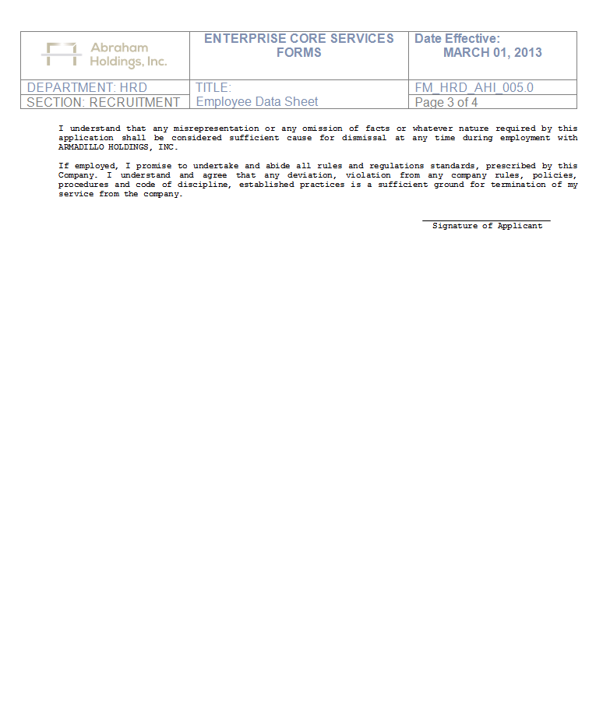

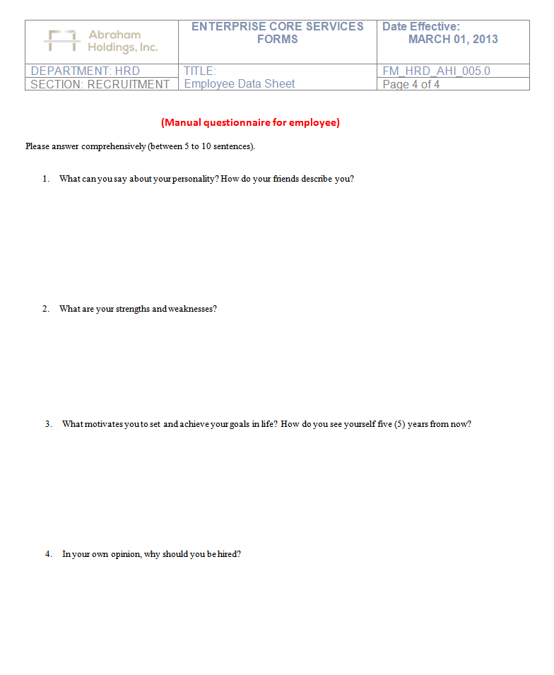

**A1.1** How to access Applicant Registration Form

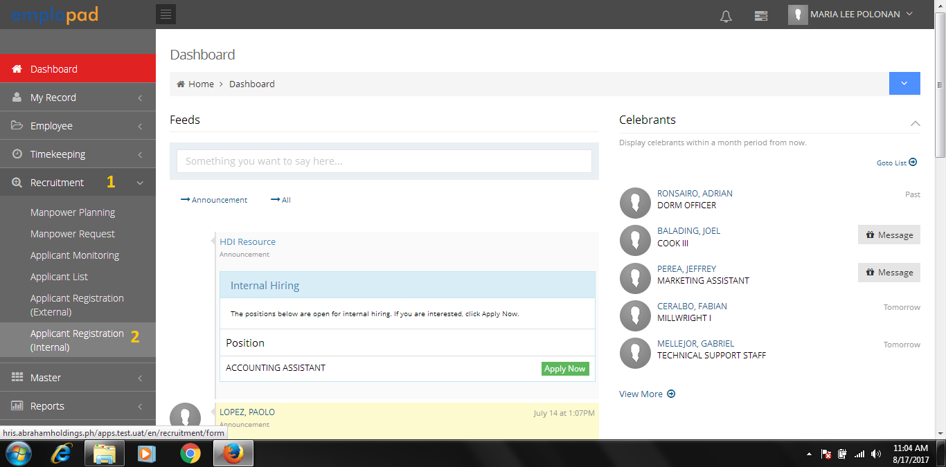

Applicant Registration (External) can be setup on company website. Entries for basic information of applicants only

Applicant Registration (Internal) can be setup on company premises. Complete information of applicants.

**A1.2** Application Form to be fill-up by the applicants or by the HRD Recruitment Staff.

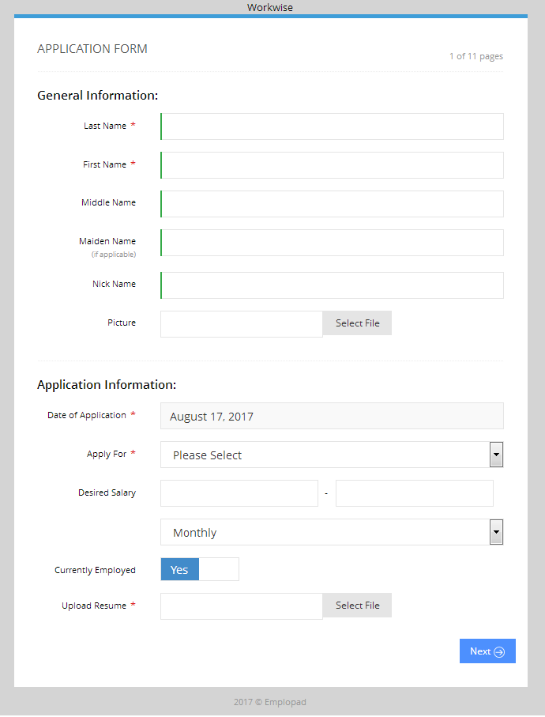

Option to upload applicant photo

List of position title from the approved PRF

Requires uploading of resume

Monthly or Hourly Rate, Default was Monthly

Complete the required information then click “Next” button

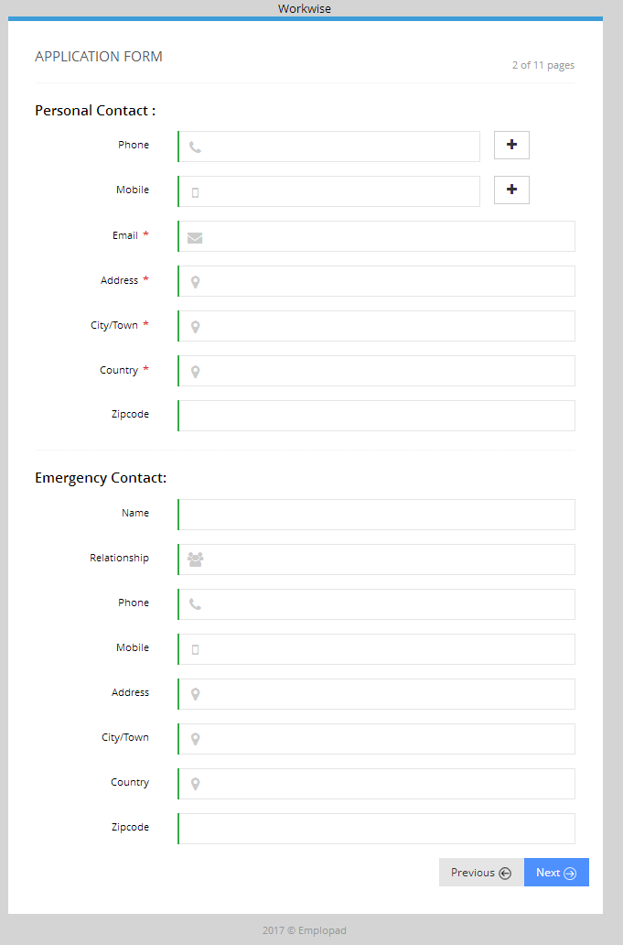

Option to add Phone Number

Option to add Mobile Number

Complete the required information then click “Next” button

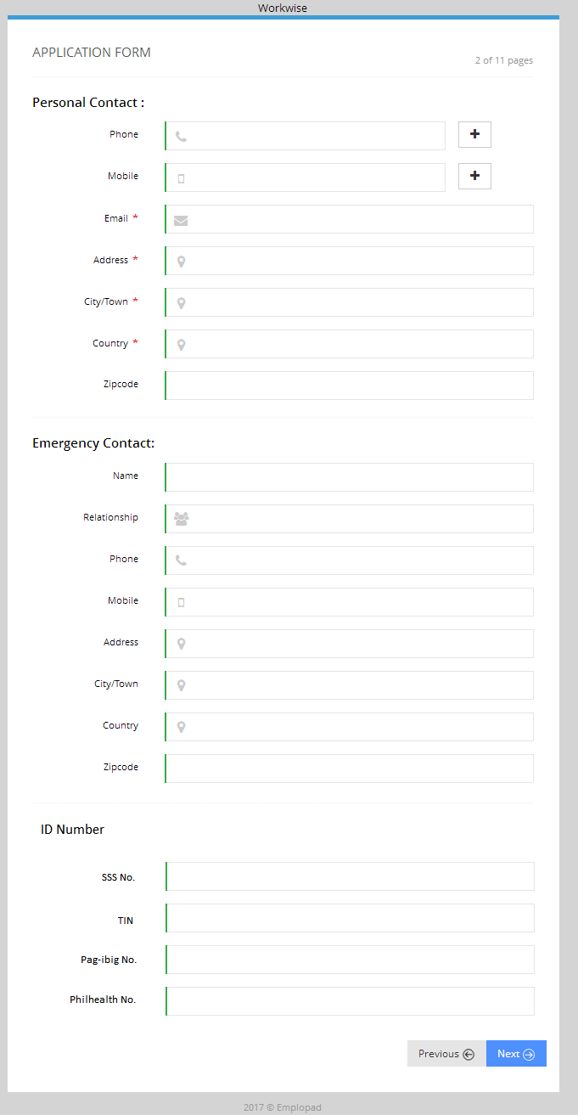

Complete the required information then click “Next” button

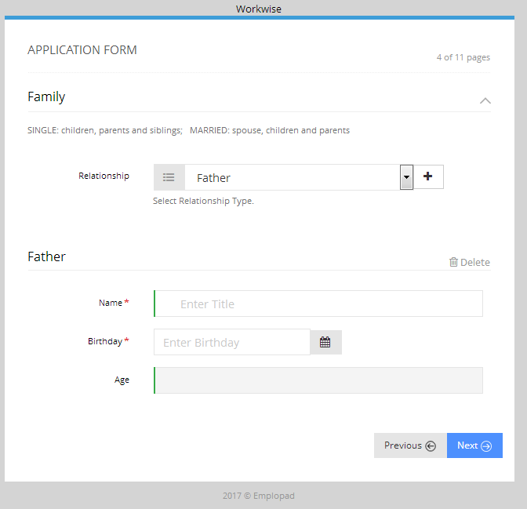

Complete the required information then click “Next” button

* Father
* Mother
* Brother
* Sister
* Son
* Daughter
* Guardian
* Spouse

To add family member, select from relationship pick list then click “+” button

Actual age will be displayed based on the Birthday

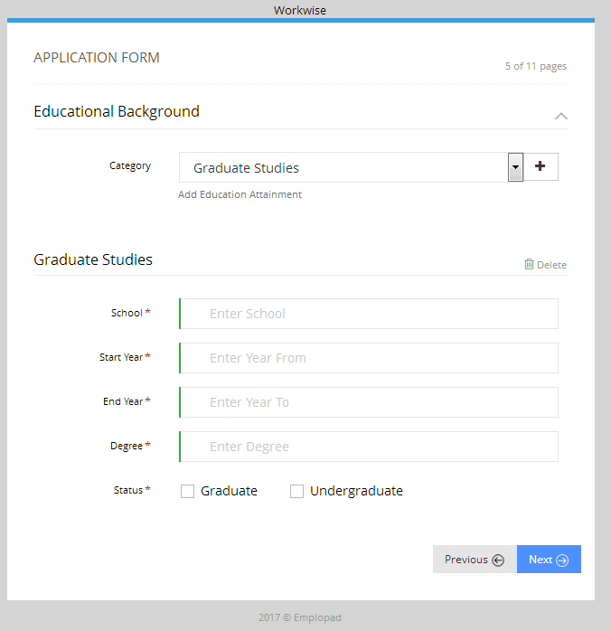

Complete the required information then click “Next” button

* Primary
* Secondary
* Tertiary
* Vocational
* Graduate Studies

To add educational background, select from category pick list then click “+” button

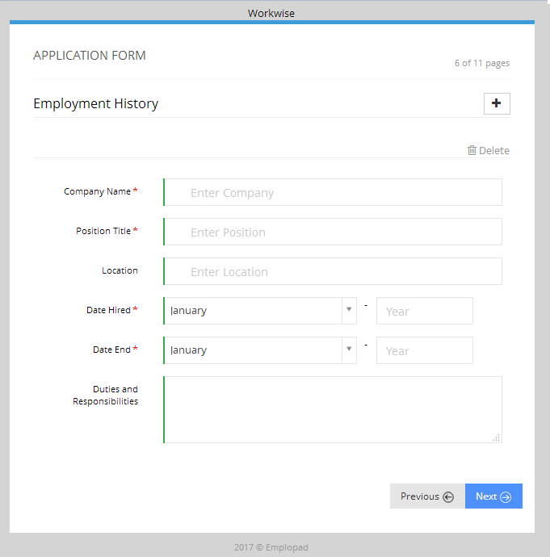

Complete the required information then click “Next” button

To add employment history, click “+” button

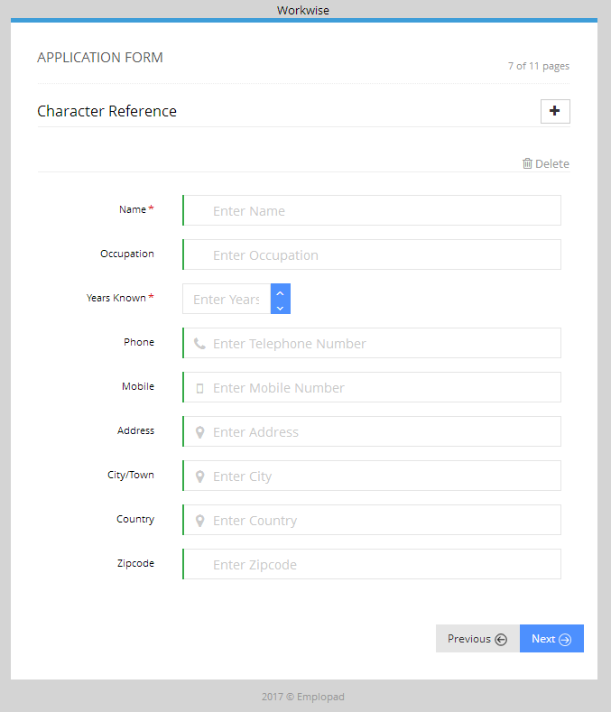

Complete the required information then click “Next” button

To add character reference, click “+” button

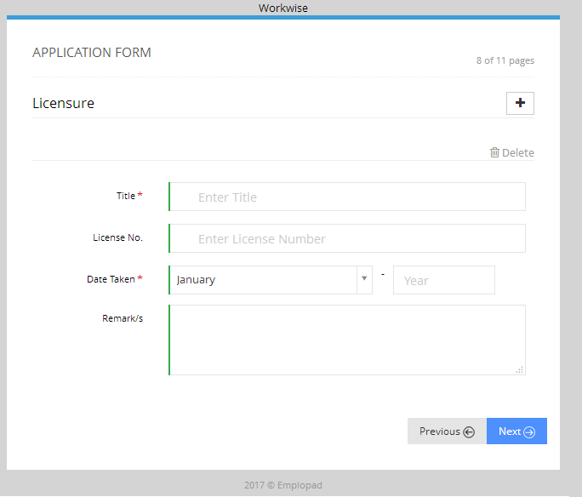

Complete the required information then click “Next” button

To add licensure, click “+” button

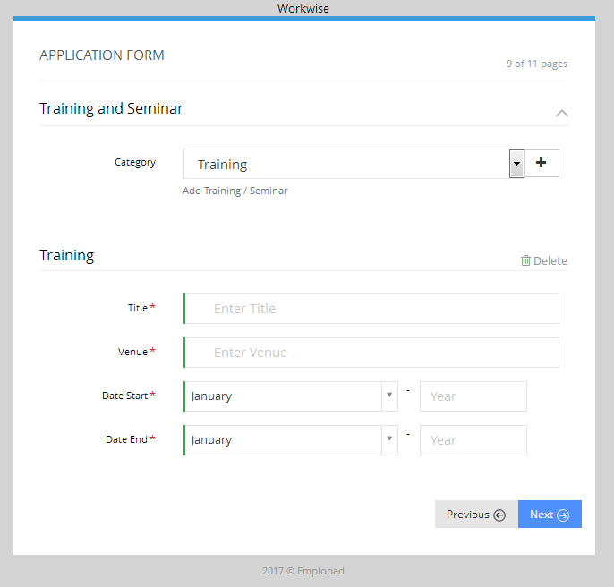

Complete the required information then click “Next” button

To add training and seminar, click “+” button

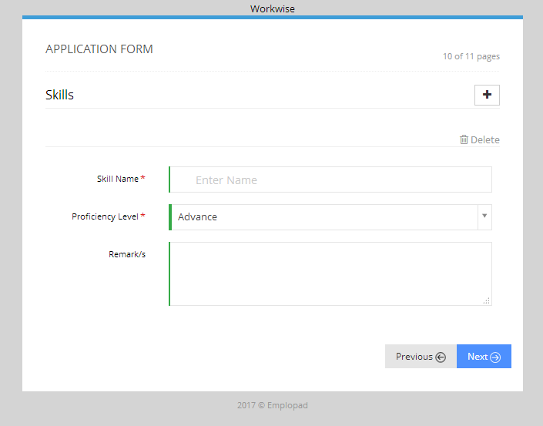

Complete the required information then click “Next” button

To add skills, click “+” button

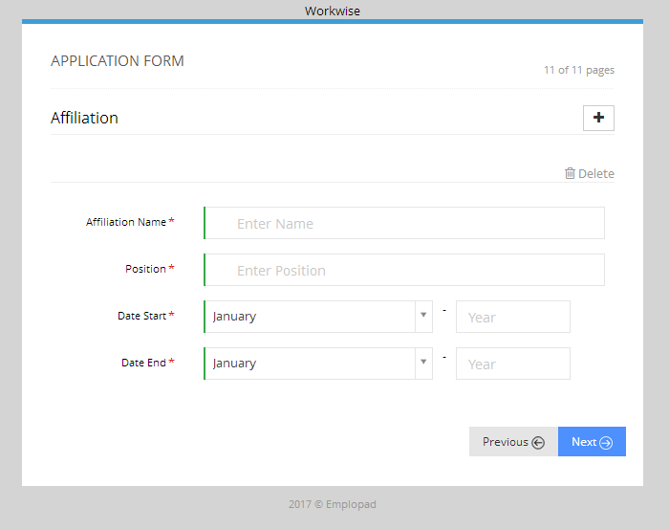

Complete the required information then click “Next” button

To add affiliation, click “+” button

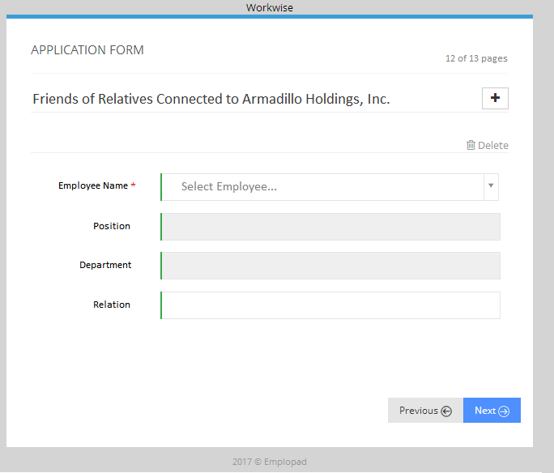

Complete the required information then click “Next” button

To add employee name, click “+” button

Additional Requirements

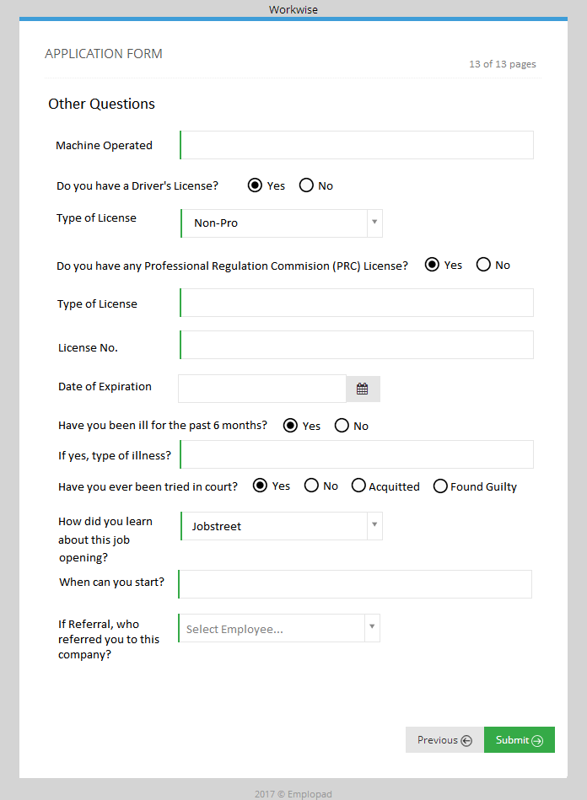

Additional Requirements

Complete the required information then click “Submit” button

**A1.3** Applicant Listing

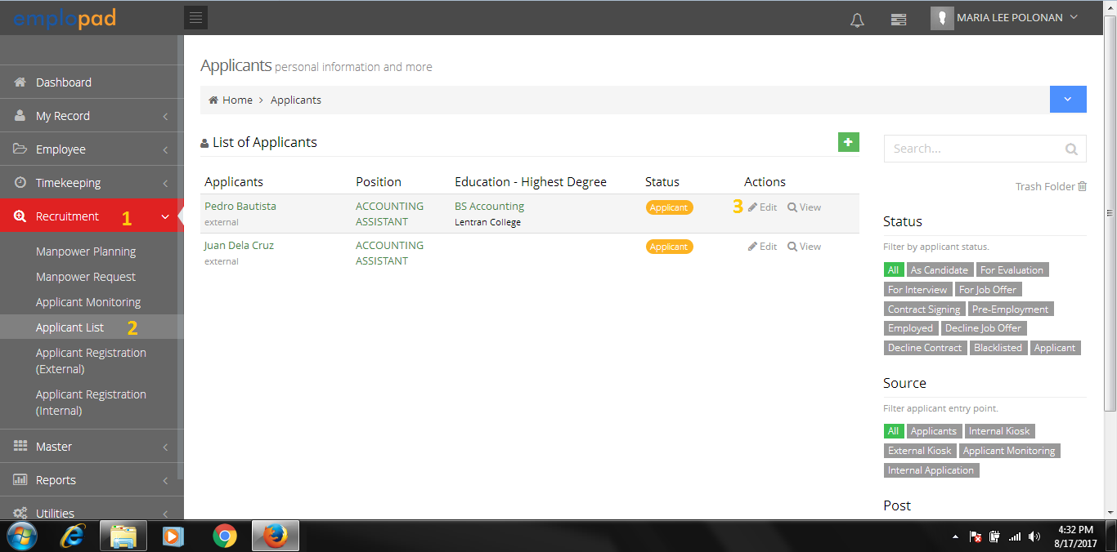

**A1.4** Applicant Information

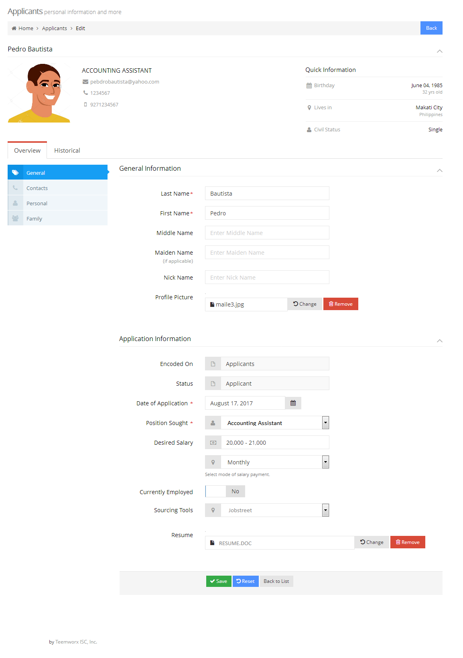

Click each tab to view the information

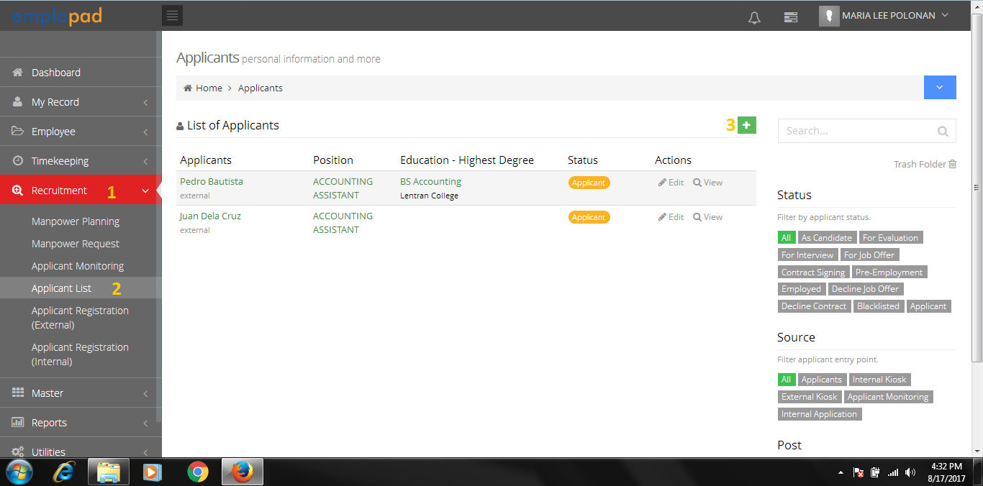**A1.5** HR Recruitment Staff can also add applicant thru applicant listing

**A1.6** Applicant Information Entry (Same content and procedure as applicant registration)

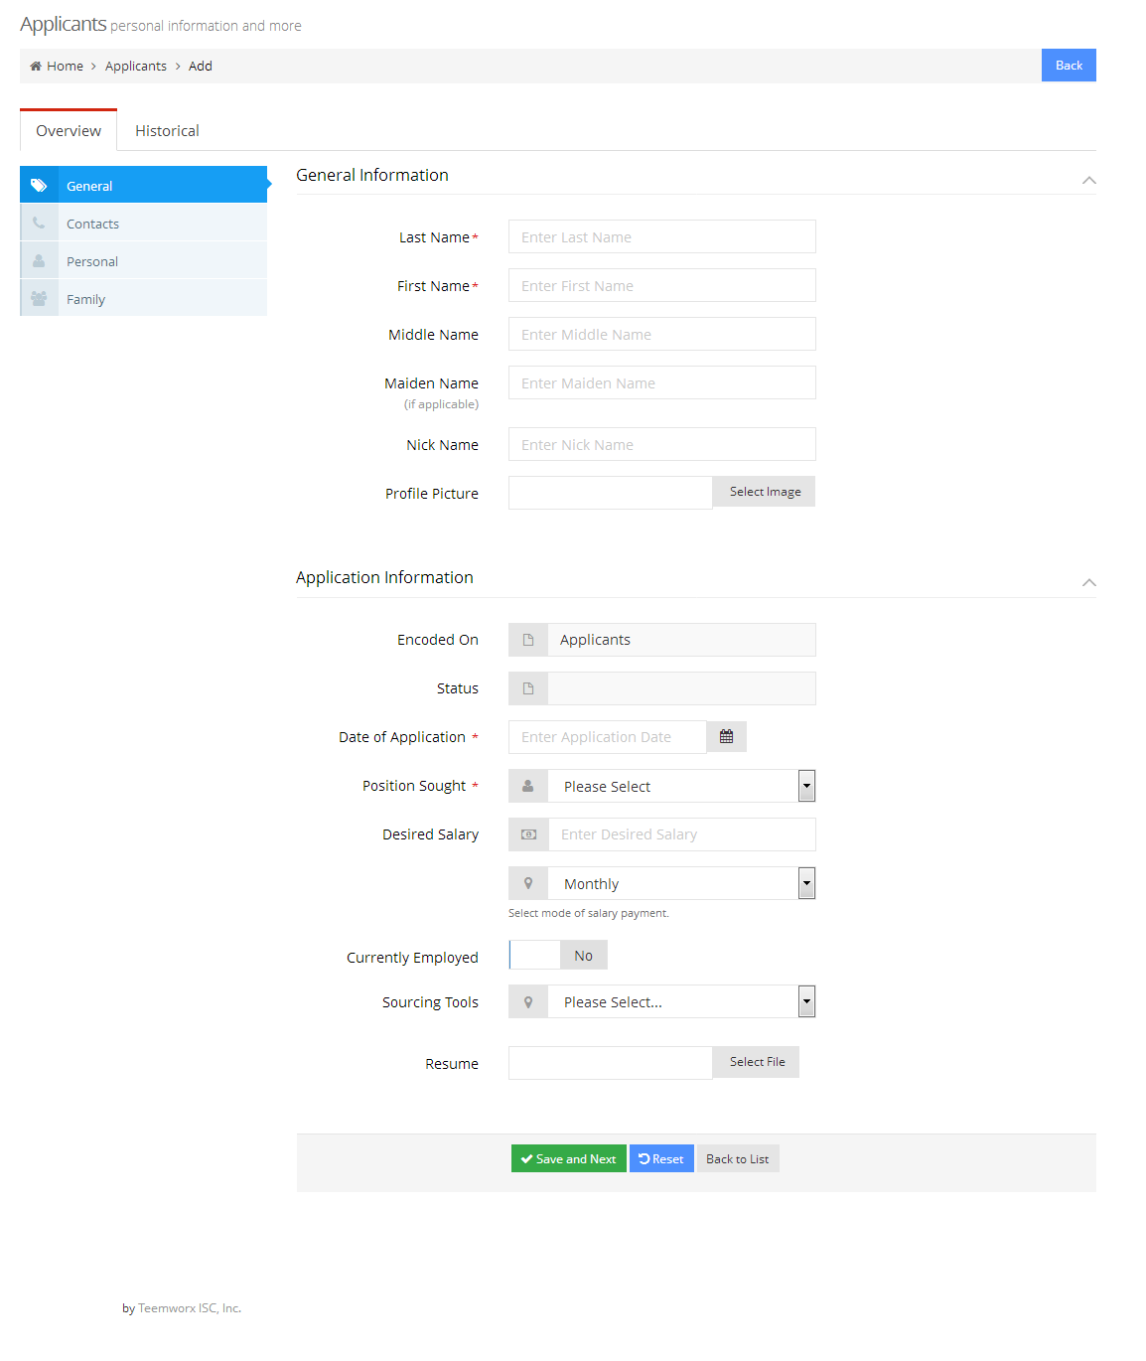

Complete the required information then click “Save and Next” button

**A1.7** Employee Data Sheet (EDS) Printing

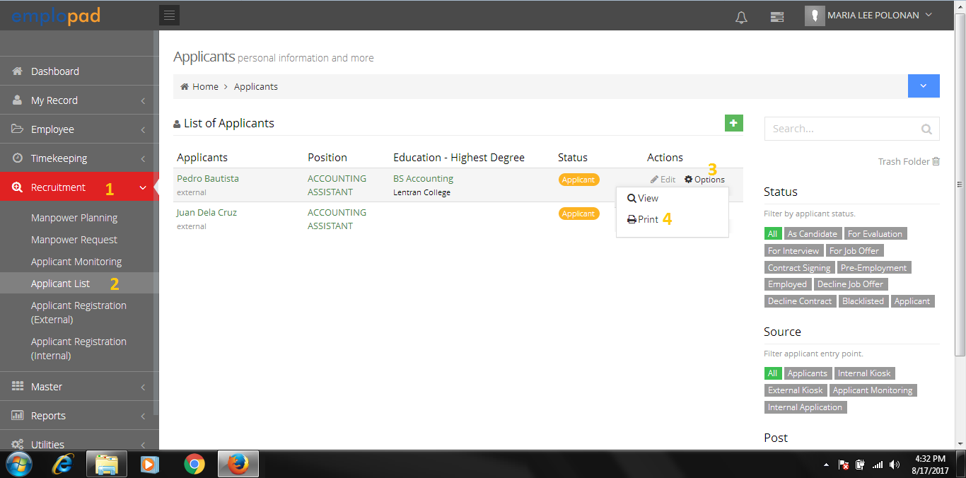

Additional Requirements

See **A1.0** for the sample EDS template

**B. Applicant Monitoring**

#### 

#### B1.0 Sourcing Candidates

List of position title for sourcing from approved PRF

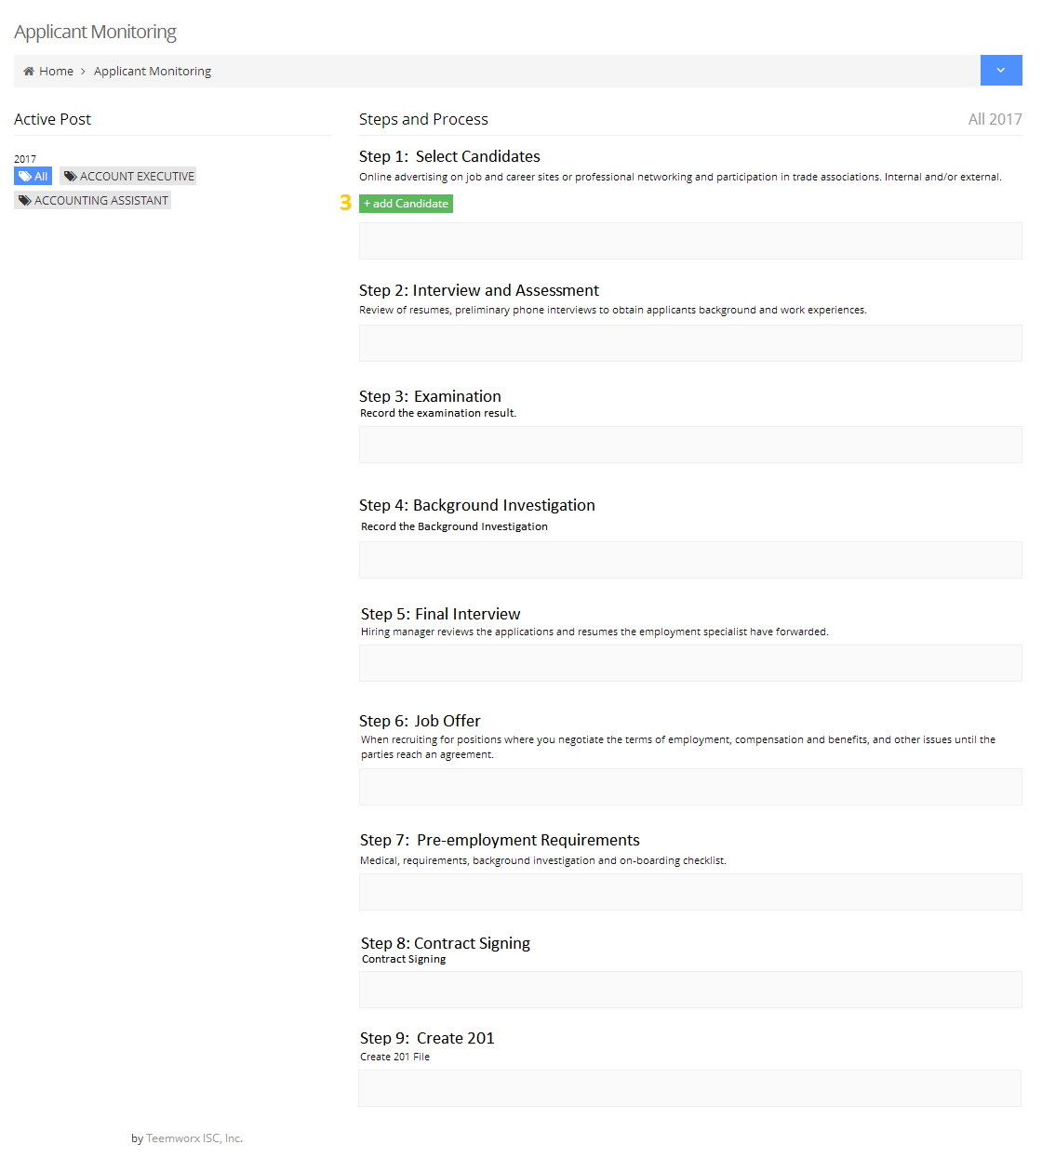

#### B1.1 Select candidate from applicant list

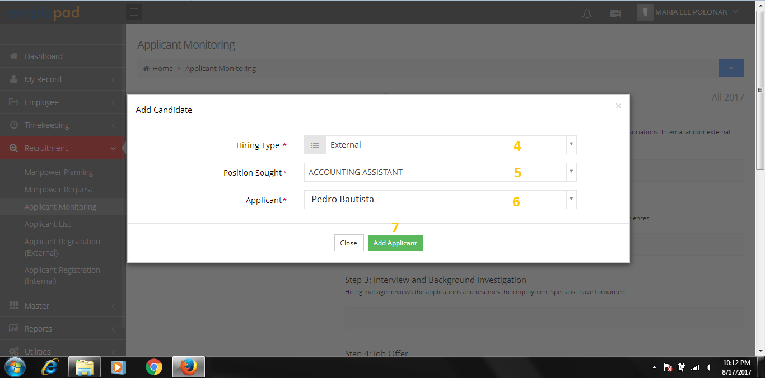

* Internal
* External

List of position title for sourcing from approved PRF

List applicants applying for the position

Selected applicant/s will be list down on the candidates

Note:

* Internal hiring was done thru employee movement.
* PRF will be attached on the movement form
* PRF will be closed was the movement (transfer) was done

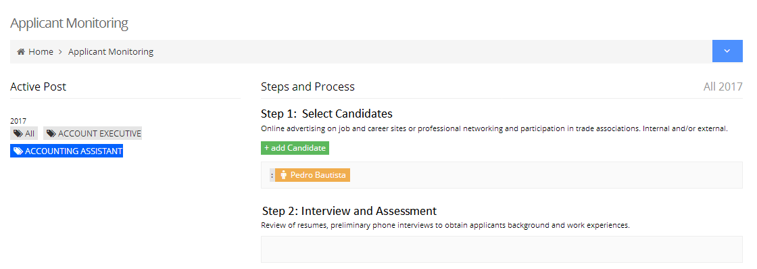

#### B2.0 Applicant Initial Interview – HRD Recruitment Staff

#### 

#### B2.1 Set the date, interviewer and location.

#### 

#### B2.2 After saving, Candidates will be move to Step 2: Interview and Assessment

#### B2.3 List of Interviewer

#### B2.4 HRD Recruitment Staff comments and recommendation entry form

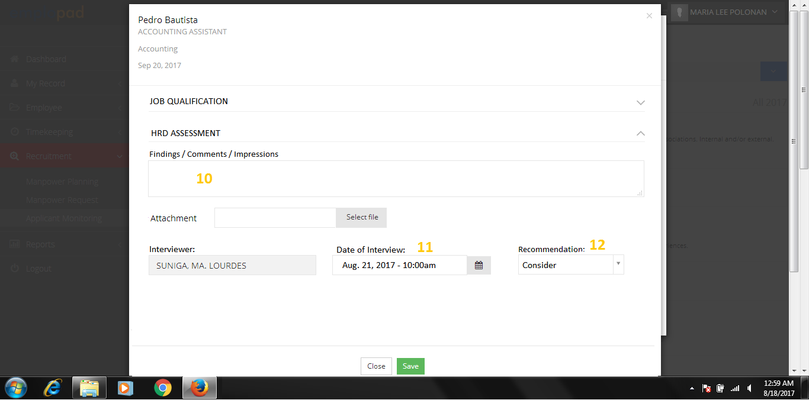

Details of Job Qualification

Option to attach EDS **A1.0** and IAF

* Consider
* Hold
* Reject

#### B2.5 Qualified applicant will proceed with the examination.

#### B3.0 Applicant Examination

#### B3.1 HRD Recruitment Staff to record the exam result then move to BI.

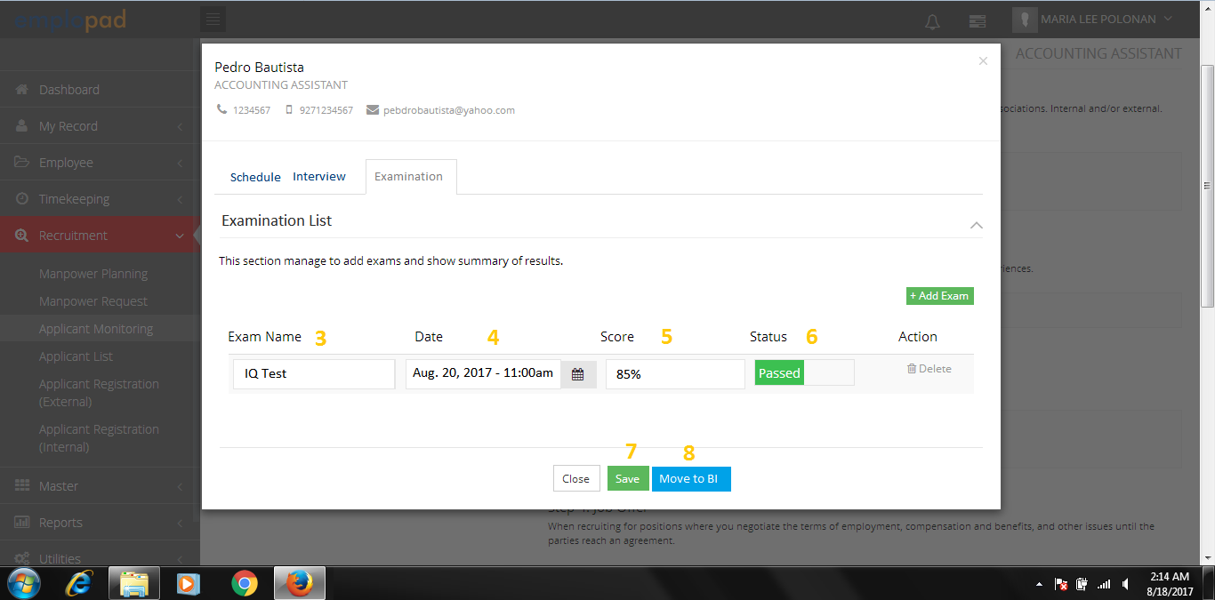

Note:

* Applicant examination are manual process

#### B4.0 Background Investigation (Optional)

#### 

#### B4.1 Background Investigation Form

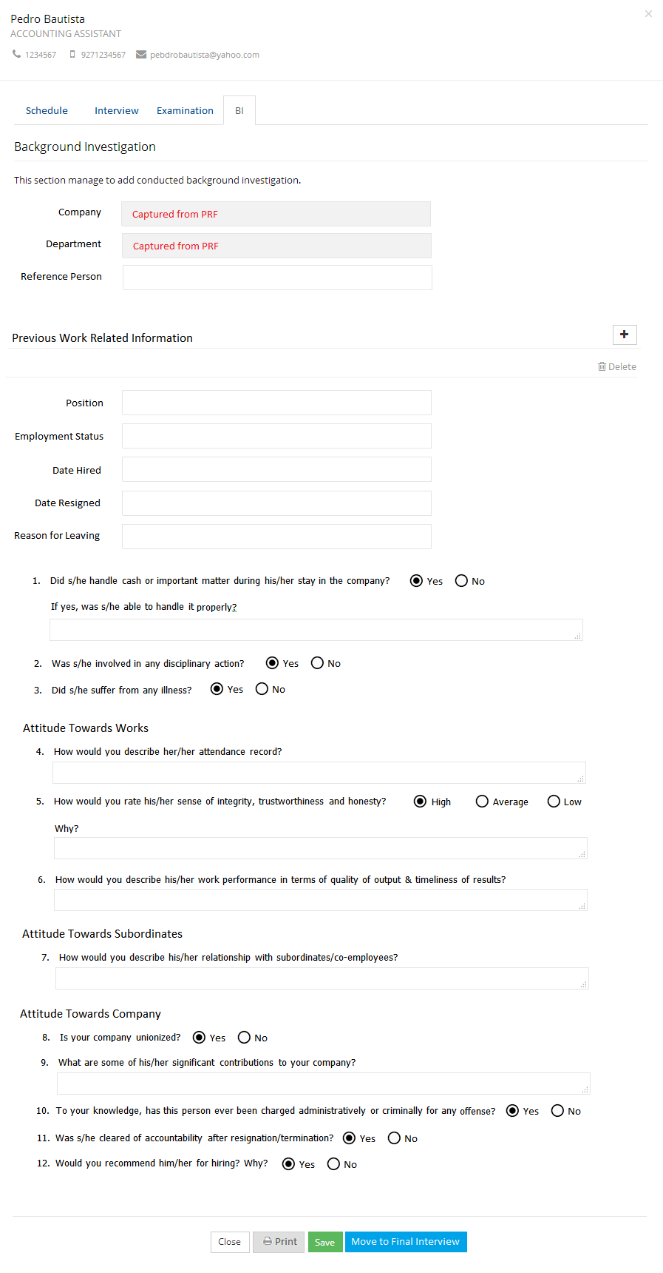

Option to print BI form **(B4.2)**

Option to add and delete previous work related information

**B4.2** 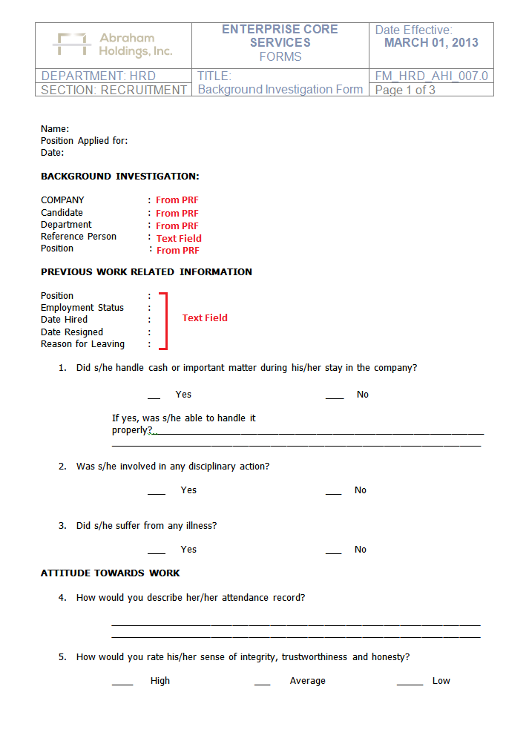Background Investigation Form Printout

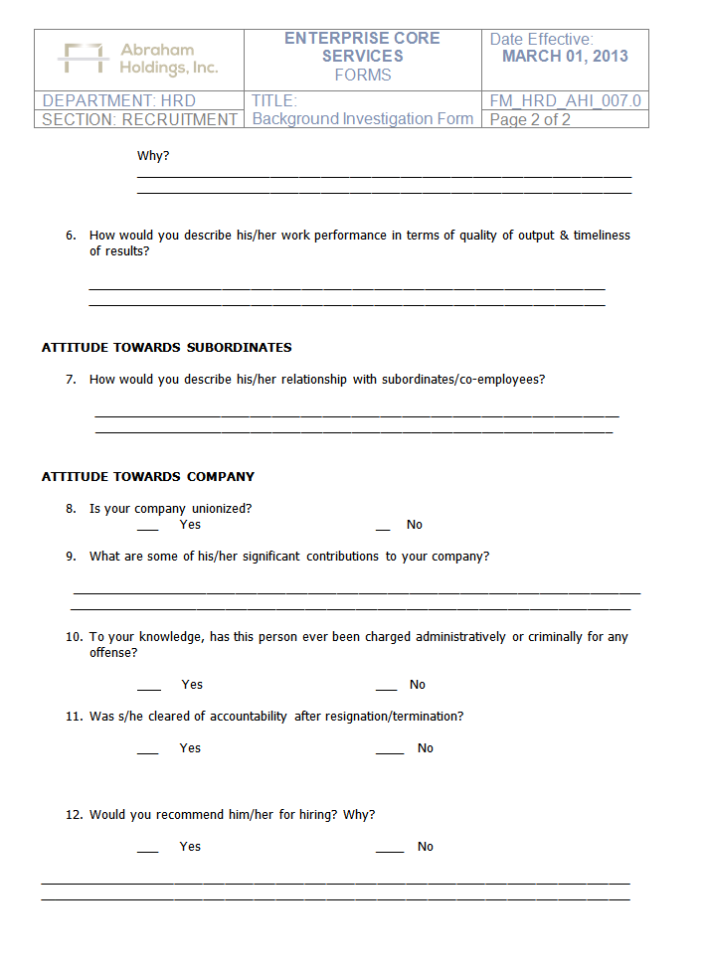

**B5.0** Final Interview – HRD Recruitment Staff to set the interview schedule

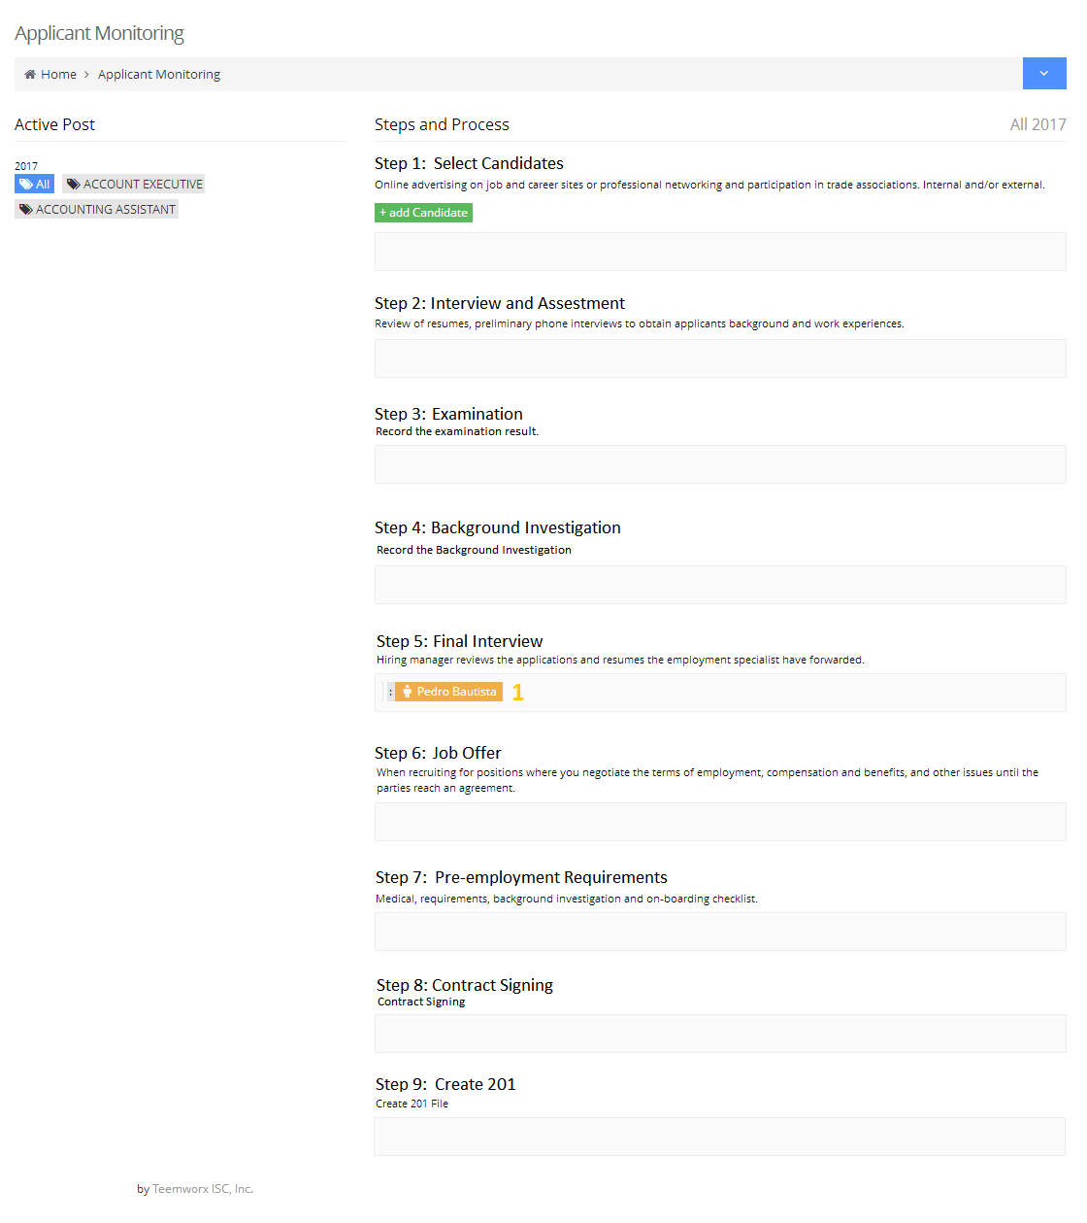

Note:

* Hard copy of Employee Data Sheet / Interview Finding Sheet / Exams will be processed manually.
* Requestor and approver can view details on the system

#### B5.1 Set the Date, Interviewer and Location.

#### 

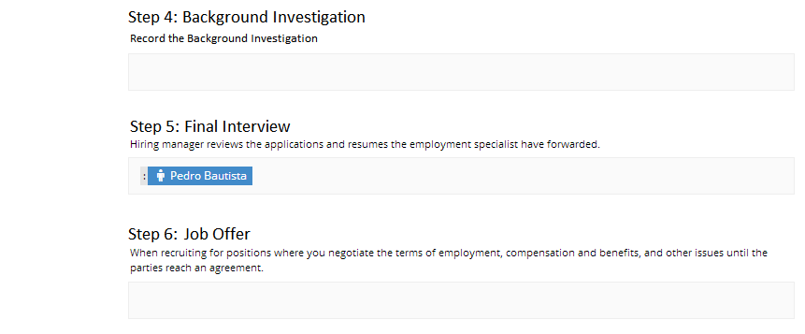

Note:

* Manual coordination with the applicant and interviewer before encoding to the system.
* Email notification will be sent to applicant and interviewer.

#### B5.2 System Notification for applicant interview will be received by the Immediate Superior and Department Head or COO.

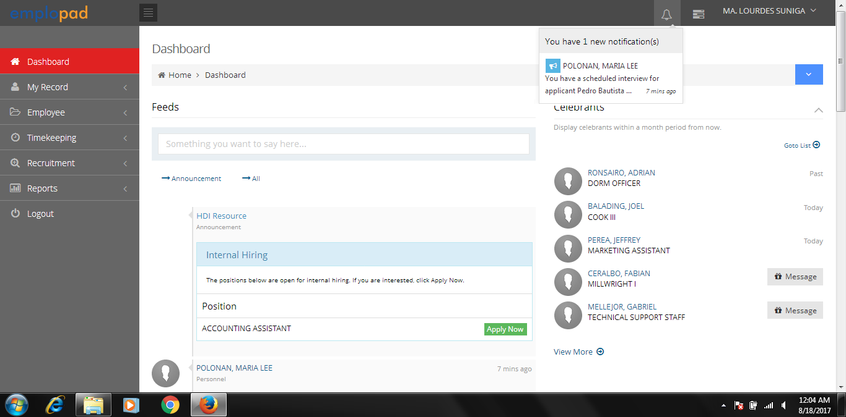

Click the notification to access the applicant interview form

#### OR

#### B5.3 Access the interview form thru Applicant Monitoring

#### 

#### B5.4 Interviewer listing, schedule and examination result.

#### B5.5 Interviewer comments and recommendation entry form

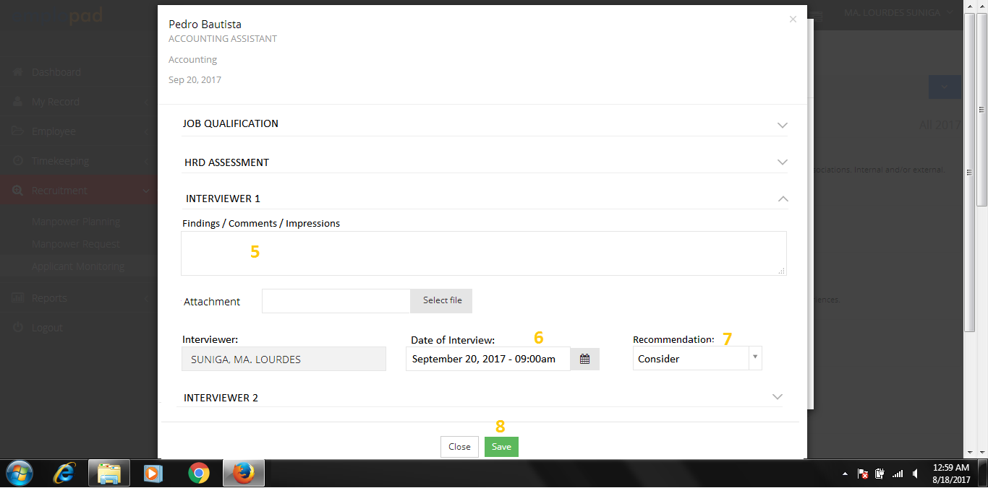

Details of Job Qualification

Details of HRD Assessment

Details of other Approver Assessment

Option to attach IAS

* Consider
* Hold
* Reject

Note:

* HRD Recruitment Staff has an option to fill-up interviewer form in behalf of the interviewer

#### B5.6 Completion of interview form will sent notification to HRD Recruitment Staff for applicant review and job offer

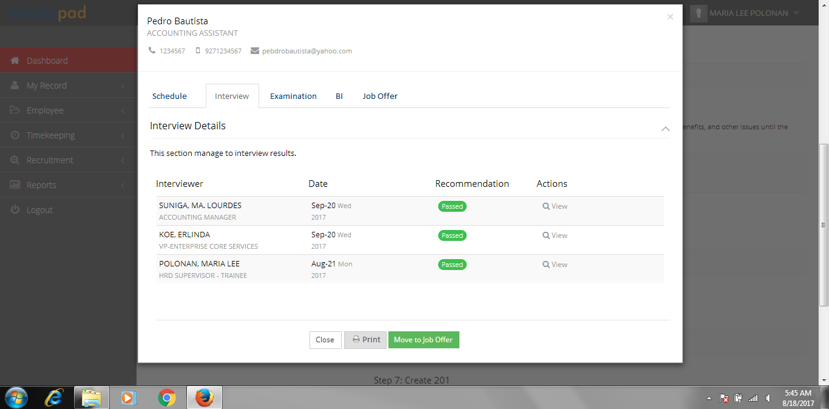

Note:

* Email notification will be sent to HRD Recruitment Staff for applicant review

Print Interview Finding Sheet **(B5.7)**

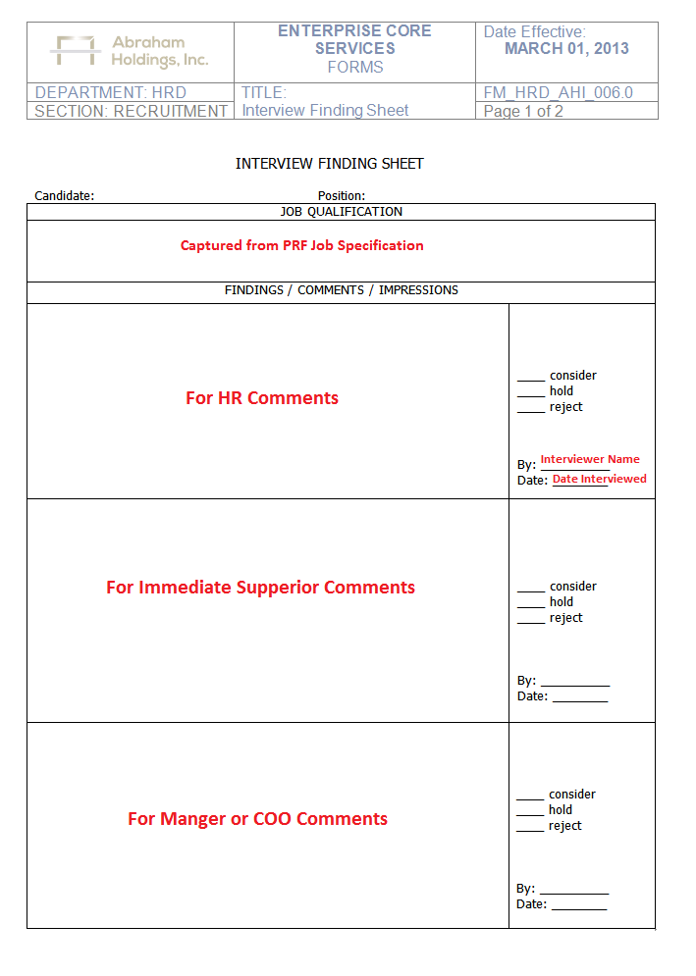**B5.7 Interview Finding Sheet**

#### B6.0 Applicant Job Offer – HRD Recruitment Staff to fill-up the job order form

**B6.1** Job Order Form - Complete the form then email to the applicant

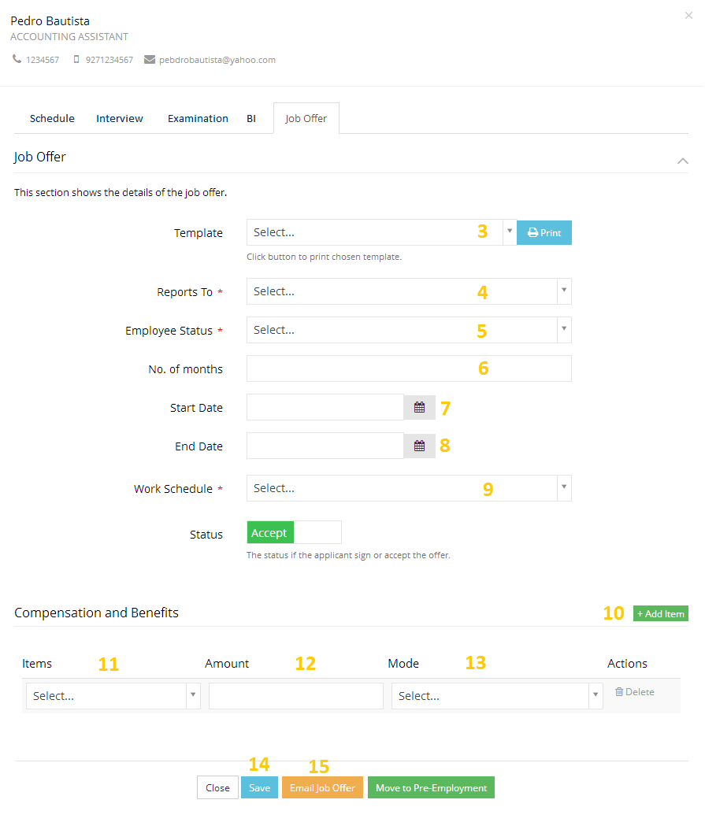

Option to Add Compensation and Benefits

Tagging if applicants will accept or decline the JO

* Casual Job Offer Template **(B6.2)**
* Probationary Job Offer Template **(B6.3)**
* Probationary Special Job Offer Template **(B6.4)**
* Hired as Permanent JO Template **(B6.5)**
* Manager Job Offer Template **(B6.6)**

Once Job Offer was accepted, proceed to Pre-employment

**B6.2** Casual Job Offer Template

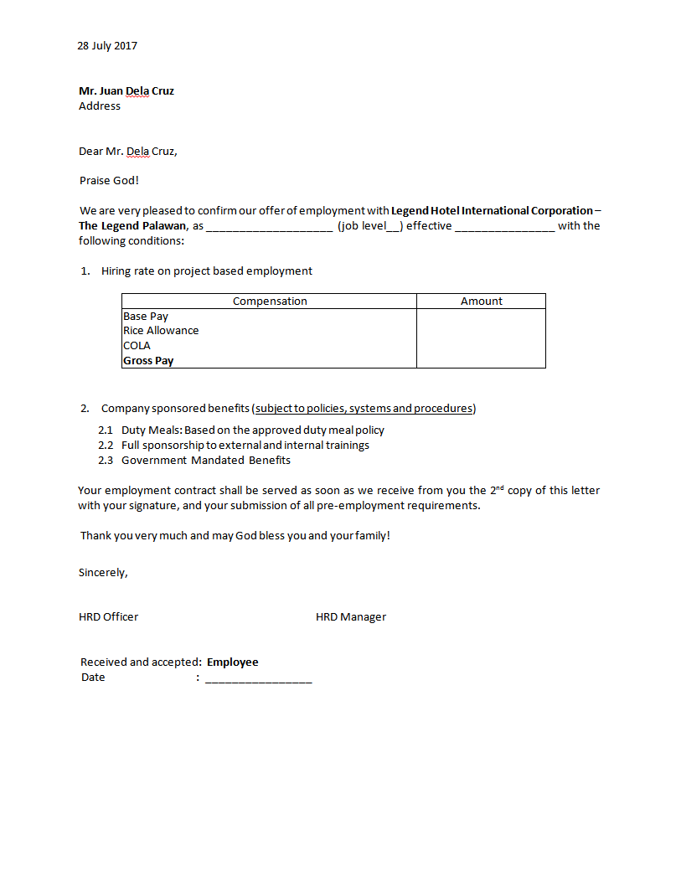

Editable by HRD Recruitment Staff before printing

Editable by HRD Recruitment Staff before printing

Value is based on the compensation defined on JO.

Name of applicant

Active employee on the system with HRD Manger Position

Applicant Information

**B6.3** Probationary Job Offer Template

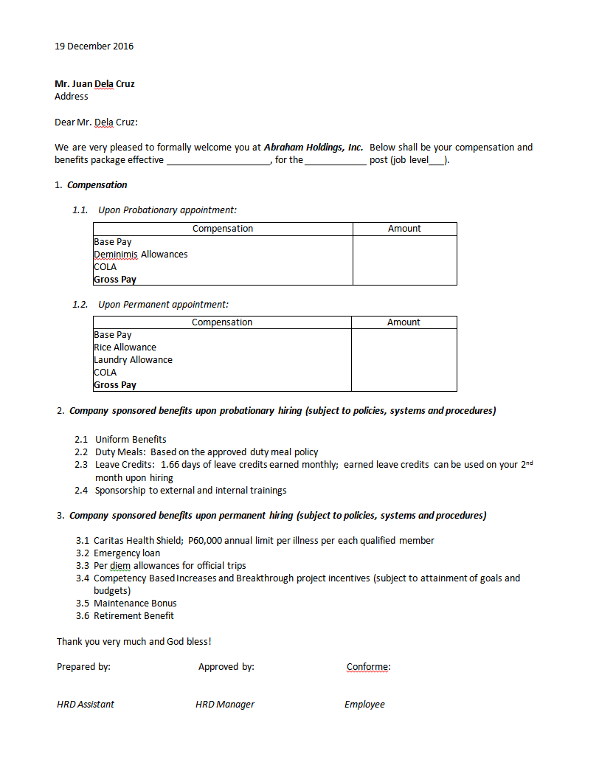

Editable by HRD Recruitment Staff before printing

Editable by HRD Recruitment Staff before printing

Value is based on the compensation defined on JO.

Name of applicant

Active employee on the system with HRD Manger Position

Applicant Information

**B6.4** Probationary Special Job Offer Template

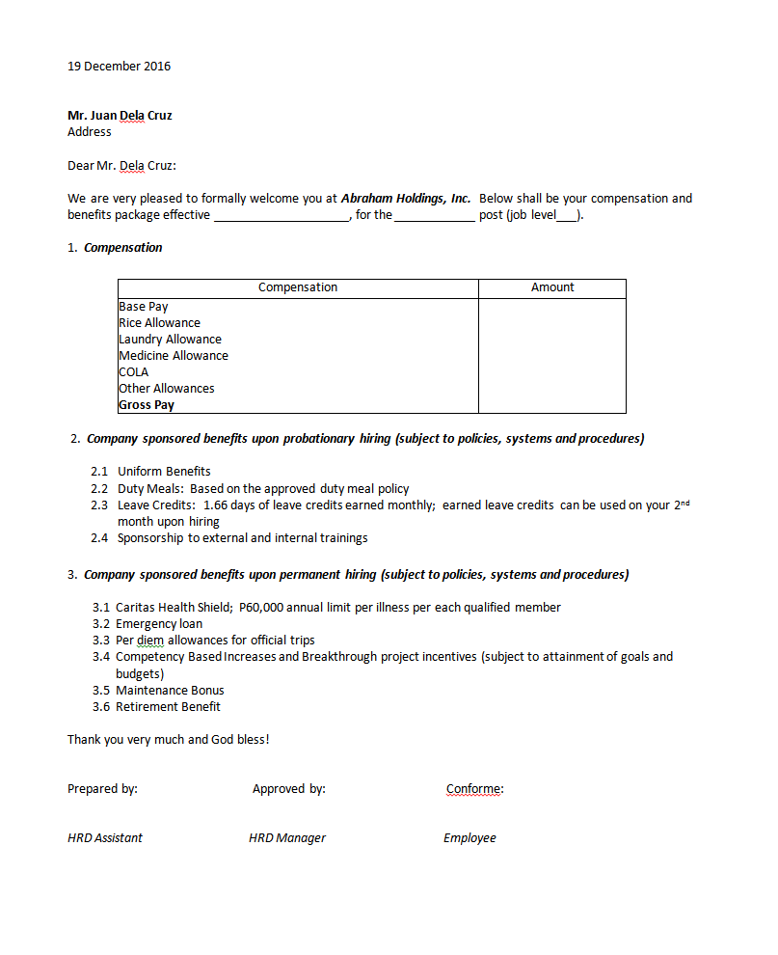

Editable by HRD Recruitment Staff before printing

Editable by HRD Recruitment Staff before printing

Value is based on the compensation defined on JO.

Applicant Information

Name of applicant

Active employee on the system with HRD Manger Position

Active employee on the system with HRD Manger Position

Name of applicant

**B6.5** Hired as Permanent JO Template

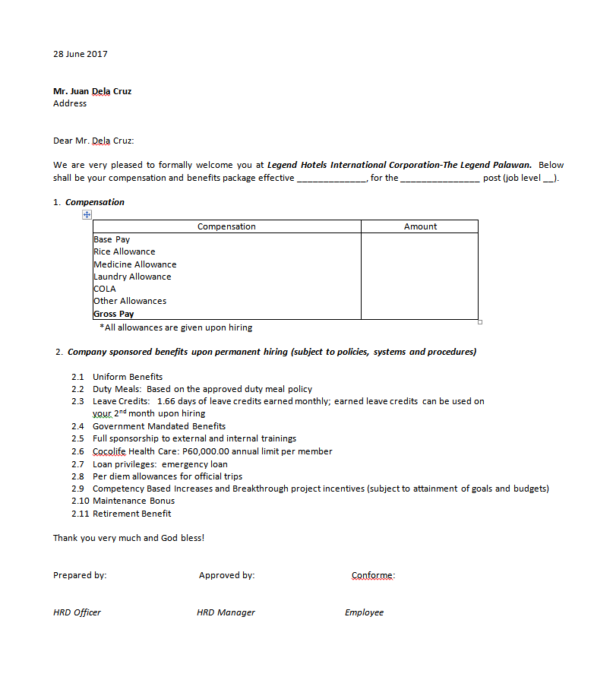

Editable by HRD Recruitment Staff before printing

Editable by HRD Recruitment Staff before printing

Value is based on the compensation defined on JO.

Name of applicant

Active employee on the system with HRD Manger Position

Applicant Information

**B6.6** Manager Job Offer Template

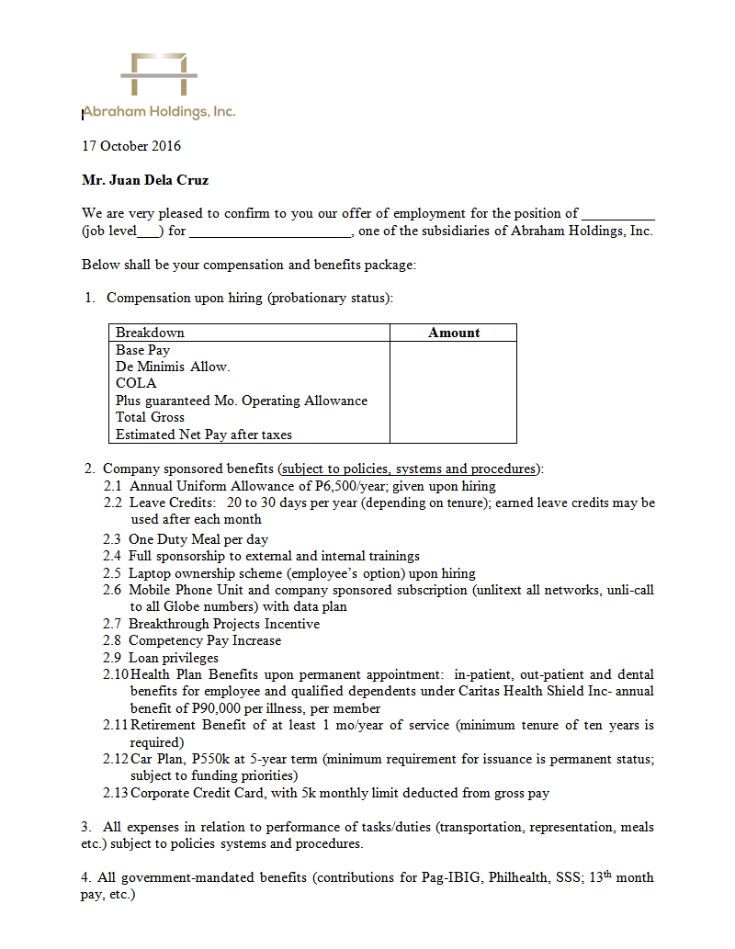

Editable by HRD Recruitment Staff before printing

Editable by HRD Recruitment Staff before printing

Value is based on the compensation defined on JO.

Name of applicant

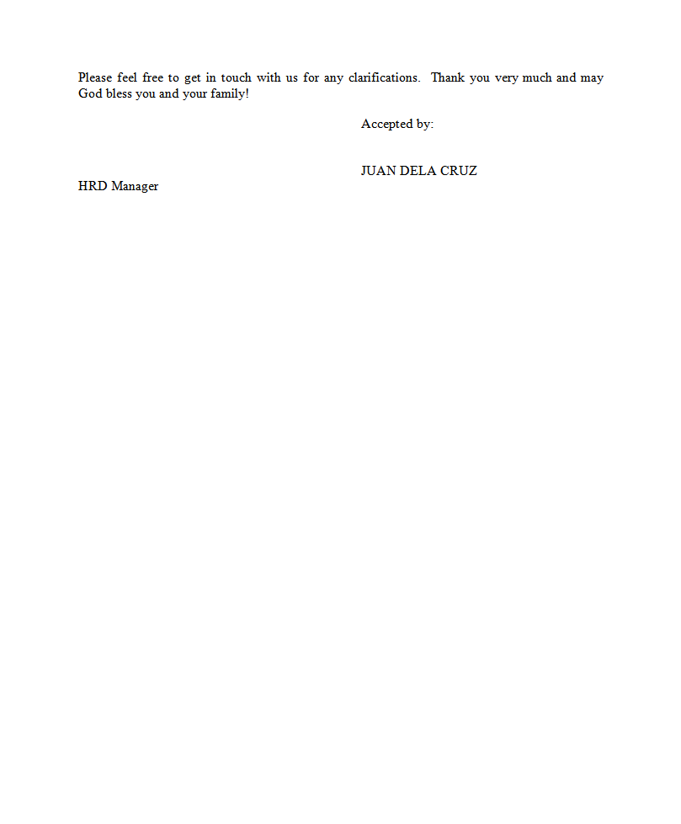

Name of applicant

Active employee on the system with HRD Manger Position

#### B7.0 Pre-employment Requirements

#### B7.1 Pre-employment Requirement Listing

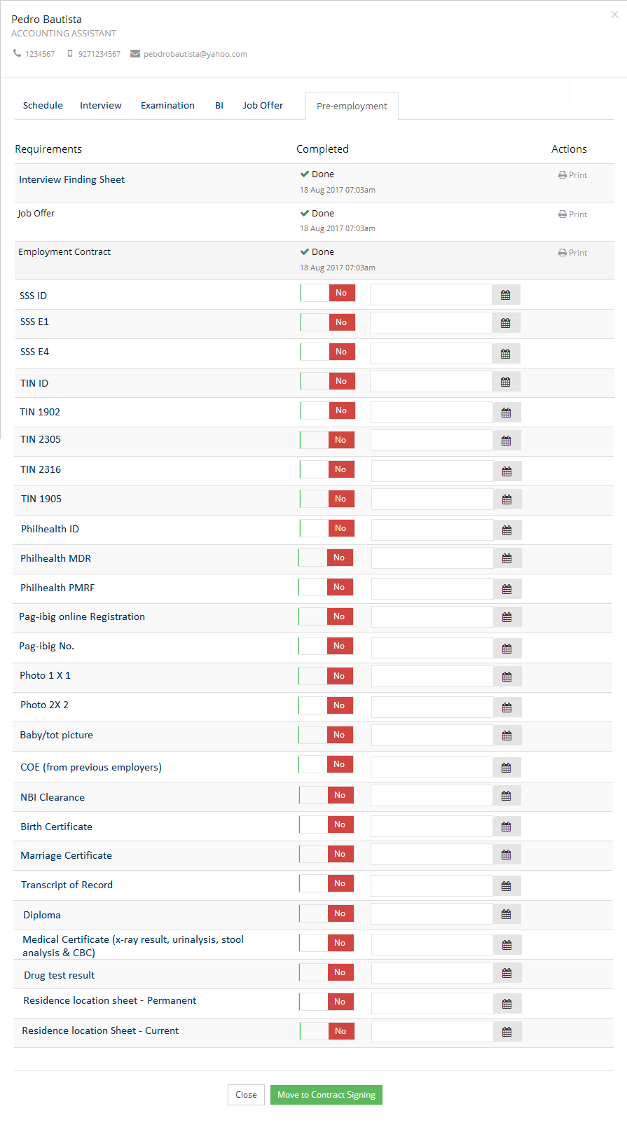

System can proceed to contract signing without pre-employment requirement.

HR to tag “yes” and enter the date and time each requirement was submitted.

Print option for IFS, JO and Employment Contract

#### B8.0 Contract Signing

**B8.1** Contract Signing Form

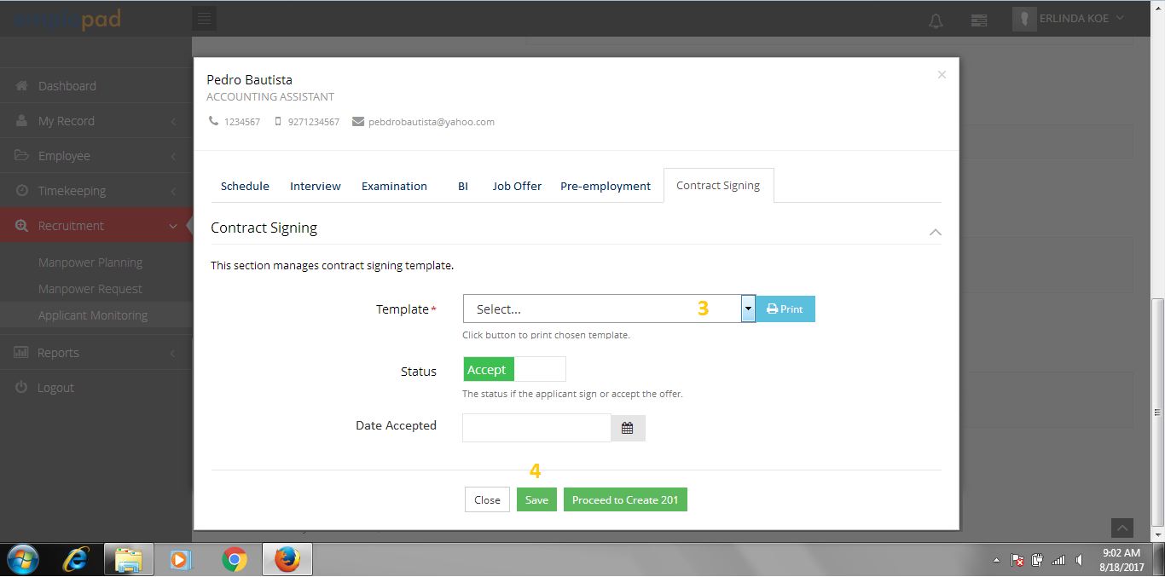

* Casual Contract Template **(B8.2)**
* Probationary Contract Template  **(B8.3)**

Note:

* Tagging if applicants will accept or decline the contract
* Date Accepted is the actual date the contract was signed
* Start date of the applicant will came from the JO.
* In-case there is a change on the start date, HR must edit the start date defined on JO.

Once contract was accepted, proceed to Create 201

**B8. 2** Casual Contract Template

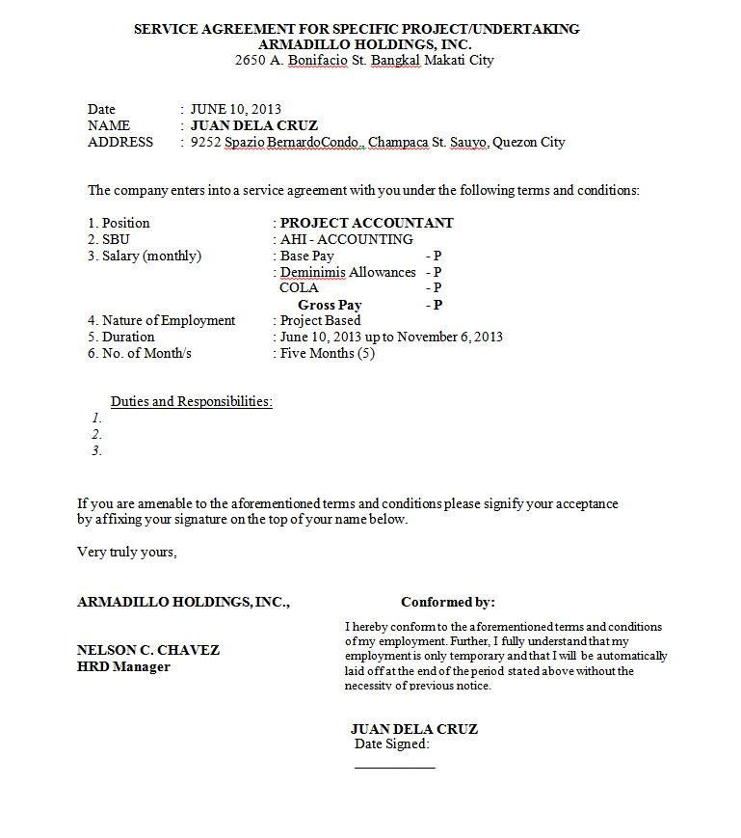

Editable by HRD Recruitment Staff before printing

Value is based on the compensation defined on JO.

Name of applicant and date accepted defined in contract signing

Company or SBU Name and address

Applicant Information

Active employee on the system with HRD Manger Position

**B8.3** Probationary Contract Template

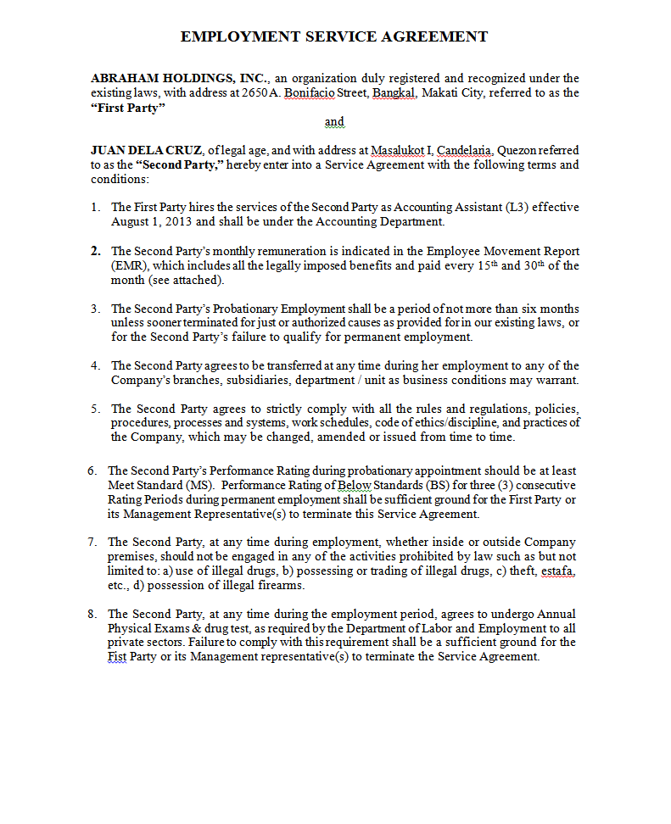

Company or SBU Name and address

Applicant Information

Note:

Template is editable for HRD Recruitment Staff before printing.

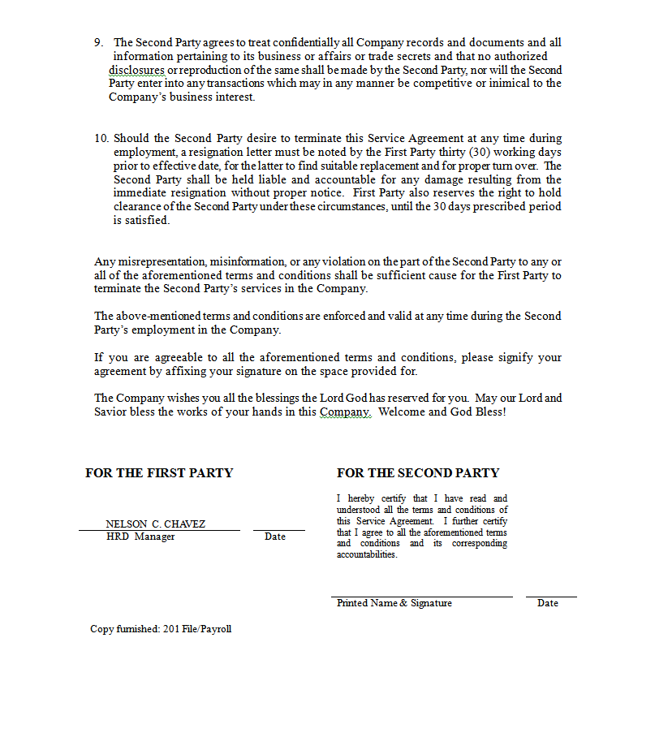

Name of applicant and date accepted defined in contract signing

Active employee on the system with HRD Manger Position

#### B9.0 Create 201

#### B9.1 Create 201 Form

#### 

Note:

* After saving “Create 201”, applicants will automatically added to employee list.
* HR must complete the employee setup such as biometric ID, leave credit setup, approvers, etc…

#### B10.0 Personnel Requisition Closing

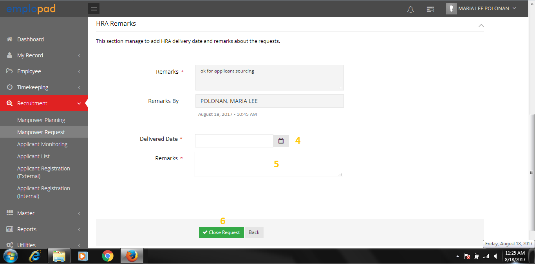**B10.1** Personnel Requisition Form – HRD Recruitment Staff to enter the Delivered Date and Remarks.

**B10.2** Personnel Requisition Listing – PRF Status Closed

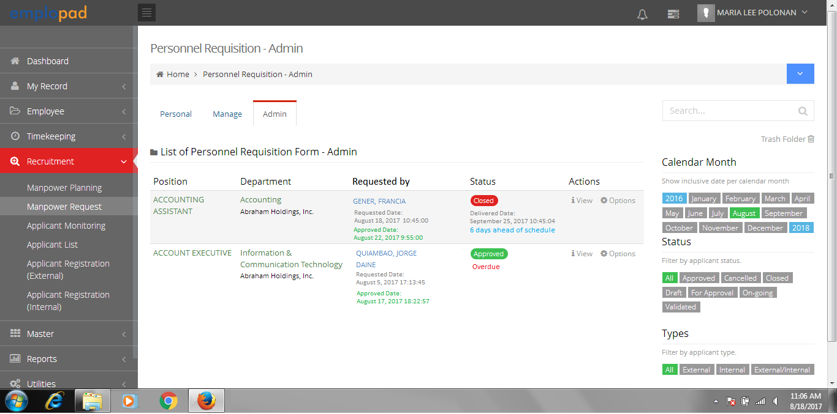

System will display the number of days left, overdue and ahead of schedule

Note:

* LEADTIME start on the approved date of HRD Manger.
* Approval of PRF is every 1st to 5th day of the month.

**LEADTIME**

45 working days – Managerial

30 working days – Technical / Supervisor

20 working days - Staff